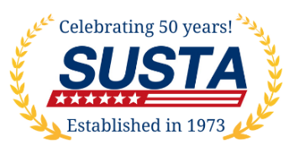 | SUSTA foreign consultant seminar  Expert Advice by Visiting In-Country Consultants  December 11, 2023 · Emeline, 181 Church Street, Charleston, SC
One-on-One Meeting Request Form
Do you want to meet one-on-one with SUSTA’s in-country consultants? While we cannot promise that you will get to meet with everyone on your list, we will do our best to accommodate your requests. Reserve in advance.
Company name:
Contact name and title:
Products you want to discuss:
Let us know which market(s) you want to meet with in order of importance to you. These are the markets available: Africa, Canada, Central America, China, Hong Kong, Europe, India and Mexico.
Market 1:
Market 2:
Market 3:
Market 4:
Market 5:
Market 6:
Market 7:

If there are any specific topics you want to address with a consultant, let us know the topic and which market:

Please return this form to Danielle@susta.org

